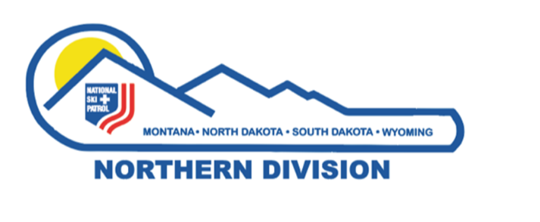

Northern Division - National Ski Patrol
Dr. Warren Bowman Outstanding OEC Instructor Award

Established: In 2018 in honor of Dr. Warren Bowman for his outstanding service to the Northern Division and the National Ski Patrol and in recognition for his invaluable contributions to the evolution of first responder and OEC education programs in the NSP.

Purpose: To honor a current member in good standing of the Northern Division, National Ski Patrol, who has been an active and current OEC instructor and/or OEC Instructor Trainer for a minimum of six years. Preference is given to those who have shown exceptional leadership and innovation in OEC education.
Each year one nominee who meets the qualifications will be selected by the Northern Division Awards Advisor/Review Board to receive the award.

Qualifications of Nominee:
- Must be a current member in good standing with National Ski Patrol. National Ski Patrol Member in good standing is a Patroller who demonstrates above average level of skills and knowledge in emergency response. Patroller displays integrity, maturity, and good judgment. Patroller has a good attitude towards ski patrolling. Patroller is cooperative, constructive and demonstrates a willingness to accept responsibilities and a desire to improve skills and knowledge. Patroller abides by rules set forth by National/Division Administration to maintain National Ski Patrol status as a patroller. Patroller is current paying National and Division dues.
- Has been an active, current OEC Instructor for a minimum of six years.
- Has demonstrated exceptional leadership and innovation in OEC education.
- Must be sponsored by an active, current OEC Instructor who is a member of the Northern Division, NSP.

Sponsors of Nominee:
- Sponsors will complete the following form and a one-page legible letter of recommendation to the Northern Division Awards Advisor by the selected deadline date.
- Note: It is an honor for all nominees to be nominated for this prestigious award. All nominations will be considered deserving if they meet the qualifications. It is the sponsor’s responsibility to write an application and recommendation letter with a strong argument for why the nominee deserves the award. The Northern Division Awards Review Board’s job is to review all applications and select for recommendation, the strongest nominee for the award. The Dr. Warren Bowman Outstanding OEC Instructor Award is based on merit as indicated by the nomination the sponsor has submitted, and it is never to become a popularity contest.
- Your signature as sponsor attests to the fact that all information you have provided is correct.

Return Nomination form and letter of recommendation to Colleen Finch, Northern Division Awards Advisor.
email: finchski200@gmail.com
1318 24th Ave SW
Great Falls, MT 59404

Submission Deadline: July 15th, 2024

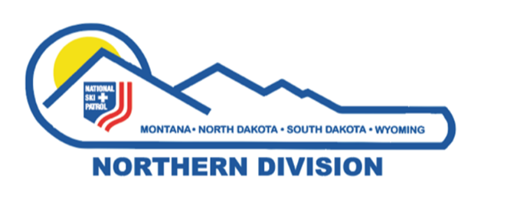

Northern Division - National Ski Patrol
Dr. Warren Bowman Outstanding OEC Instructor Award

Nominee’s Name:

NSP #: __________________ Nominee’s Registered Patrol:

Nominee’s Address: ________________________
The form has a simple format to enable sponsors to complete. If you have questions or concerns, contact the Northern Division Awards Advisor
Column A: Verify the criteria has been met
Column B: If known complete (if unknown the Northern Division Awards Advisor may obtain or request additional information from the Northern Division Registry)
Column C: To be completed by the Awards Advisor/Northern Division Review Board

Nominee | A  Y(yes) | B  Years and dates/Additional Information  (Complete if known) | C  Awards Committee Column
1. Current member-good
standing
2. Active OEC Instructor
minimum 6 years.
3. Current OEC Instructor

4. Dedication to NSP (describe):

5. Innovation in OEC education (list examples):

6. Leadership (list positions and examples):

7. Recommendation letter  from sponsor attached |  | Letter may include: past acknowledgements, special trainings, other Division NSP attributes to the Division, personal knowledge. Sponsor comments
Name of sponsor:

Address of Sponsor:

Current Position of Sponsor in Northern Division:

Signature of Northern Division Awards Advisor ____________________________________ date ______________

Dr. Warren D. Bowman

Warren Daniel Bowman Jr., M.D., a renowned ski patroller, physician, mountaineer, outdoorsman and author, died on March 3, 2017, at his home in Billings, Montana. He was 87 years old. "Warren represented all of the best of the National Ski Patrol," said NSP National Board Chair Jim Woodrum. "His pioneering efforts to train ski patrollers in Outdoor Emergency Care have helped save many lives.

The ski industry is forever grateful for his vision, selflessness and hard work." Dr. Bowman was a committed patroller, serving as medical adviser to the National Ski Patrol for 30 years and writing the acclaimed medical textbook "Winter Emergency Care," as well as three subsequent editions of the textbook. He was an acknowledged expert source for ski patrol systems across the globe and was the recipient of the 1989 Award of Excellence in Education from the American Society of Association Executives. He was also extremely active in the Wilderness Medical Society. He was the recipient of many of the National Ski Patrol's highest honors for his exemplary service, including the National Outstanding Ski Patroller Award in 1977 and 1987 and multiple Distinguished Service Awards. He was inducted into the National Ski Patrol Hall of Fame in the inaugural class of 2013.

In 1990, Warren was recognized with the Minnie Dole Award. This extremely rare award recognizes those exceptional patrollers who have closely exemplified the long-term dedication, devotion, and self-sacrifice of NSP founder Charles Minot "Minnie" Dole. "Warren was a thoughtful, generous, kind and gentle man with a great sense of humor, and I have always felt honored to have known him," recalled long time fellow patroller Mike Huber, an NSP board member. Current NSP National Medical Adviser David Johe, M.D., stated, "Warren was my mentor and a very good friend. He loved the ski patrol, and his kind demeanor was unsurpassed. I will miss him."

Dr. Bowman was born on Jan. 4, 1930, in Richmond, Va., the first child of Dr. Warren D. and Olive Smith Bowman. He grew up in Washington, D.C., graduated from Bridgewater College in Virginia in 1950, and received a medical degree from the University of Pennsylvania in 1954.

Warren had a lifelong love of the outdoors and joined the Billings Clinic in 1960 in part because of the access to Montana's unique and beautiful wilderness. He started at the clinic as a general internist and soon became one of the first board-certified hematologists and oncologists in the region. He was deeply respected and saw thousands of patients from Montana and Wyoming over nearly 40 years of practice. He is survived by his wife, Dorothy; his children, Carolyn, Joan, Amy and Eric and their spouses and children; and by his stepchildren, Mary and Steven, and their spouses and children.

