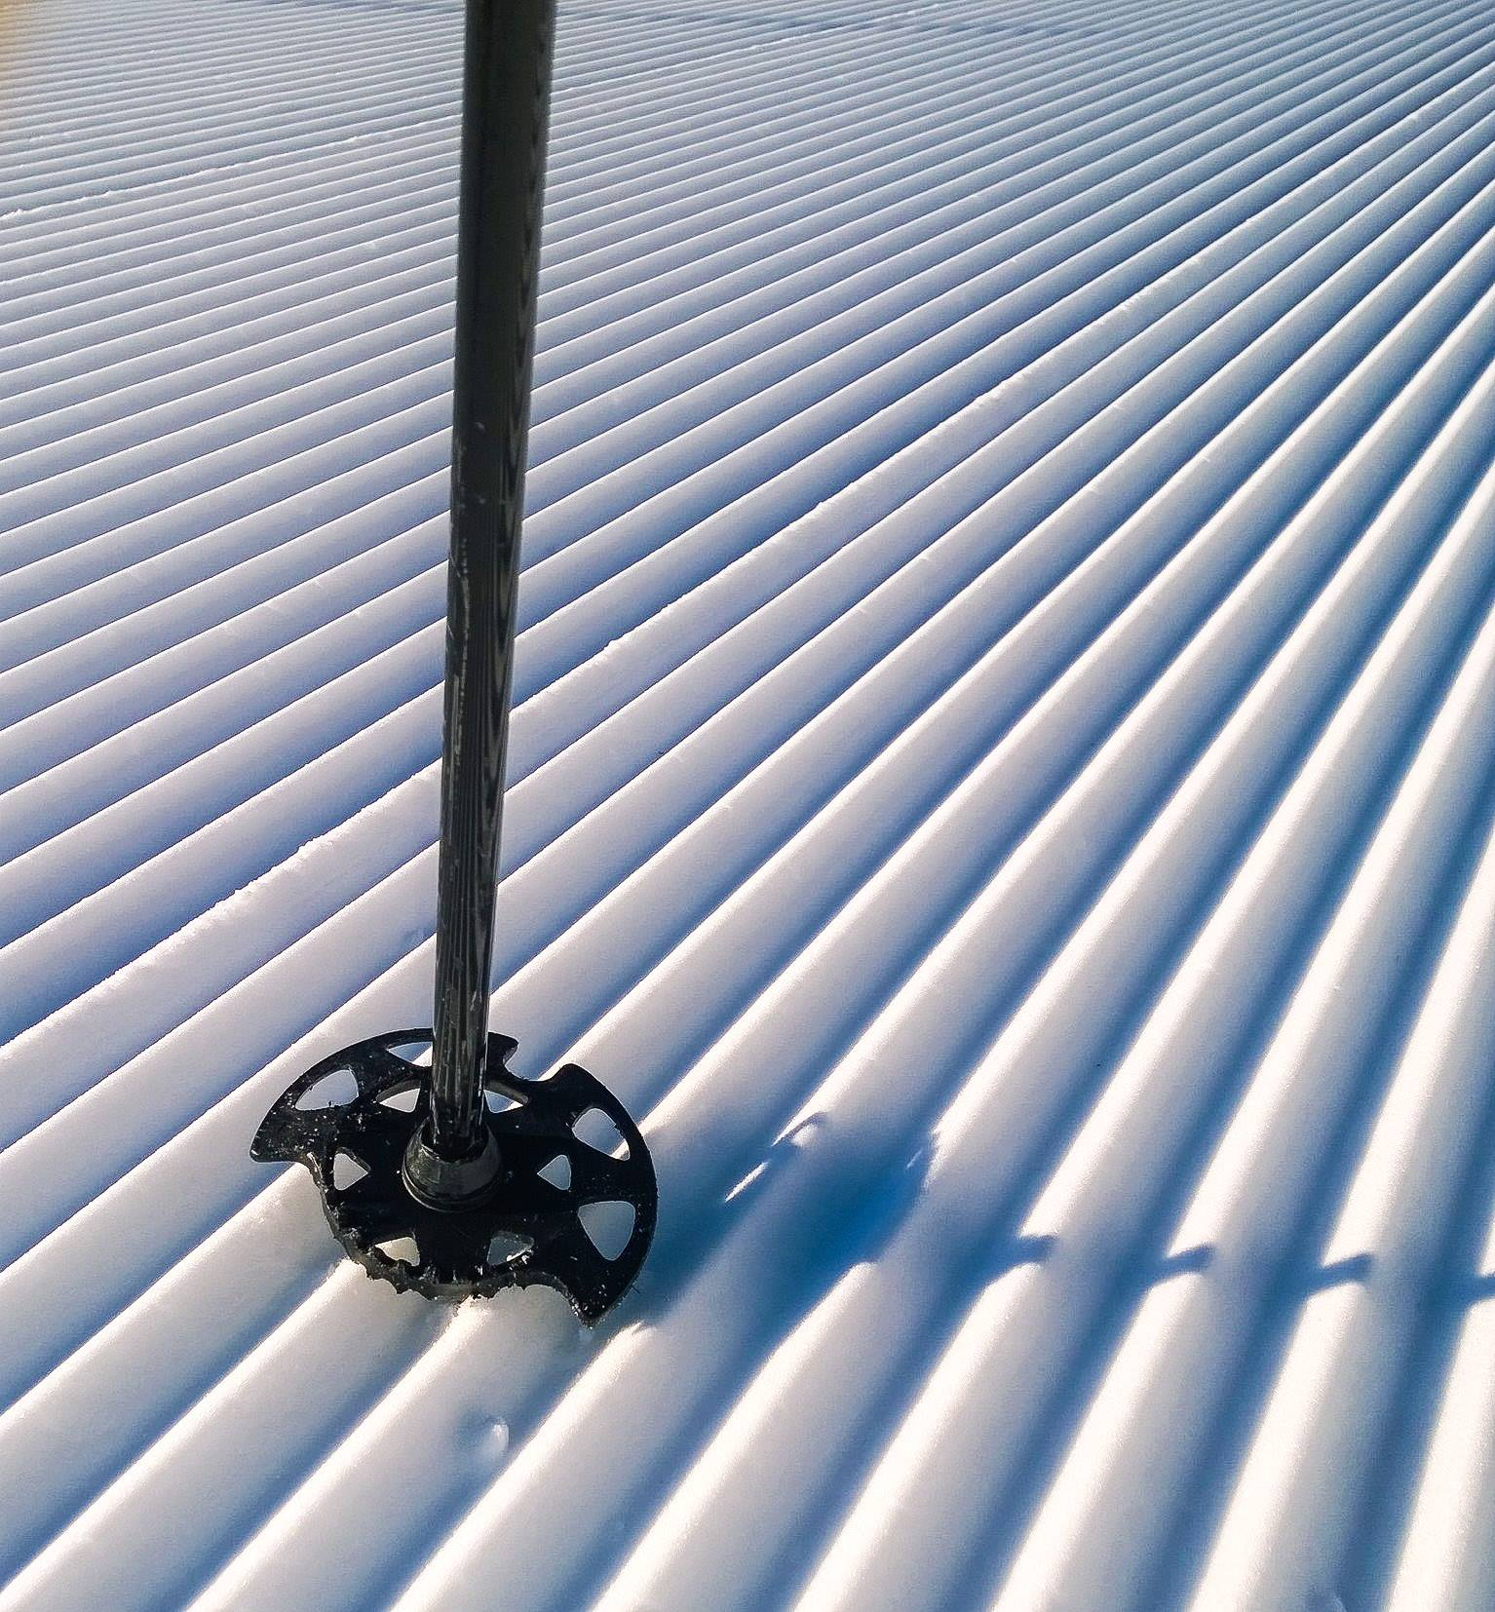
Photo credit: Jan Nelson.
Have you taken a break or retired from patrolling? If you want to stay connected with NSP and were a patroller for at least one year, you can become an alumni member.
Alumni membership is a way for former patrollers to remain affiliated with NSP. You can choose how involved you want to be, whether as an instructor or with your local patrol. You always have the option to go back to patrolling with current OEC and your patrol rep’s approval.
For only $30 a year, you’ll receive benefits including:
- Member voting rights;
- Ski Patrol Magazine;
- Sweep and Sweep Deals monthly e-newsletters;
- Discounts through the Ski Patrol Catalogs and NSP Pro Deals Page;
- Education resources; and
- Online access to the NSP website.

Become an alumni member today, and join over 2,800 other alumni who help support our great organization. Send in the form below with a check or money order for $30 made payable to National Ski Patrol to:
National Ski Patrol
133 S. Van Gordon St., Suite 100
Lakewood, CO 80228
BECOME AN ALUMNI MEMBER TODAY!
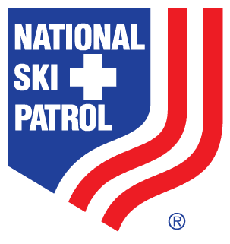
New Alumni Registration Form

133 S. Van Gordon St. ▫ Suite 100 ▫ Lakewood, CO ▫ 80228
Phone: (303) 988-1111 ▫ Fax: (303) 988-3005 ▫ Email: nsp@nsp.org

Name NSP Member #

Address Phone

City State Zip

Email Birth Date Nat’l Appt/LCA #

